Quick Start
- Book Search
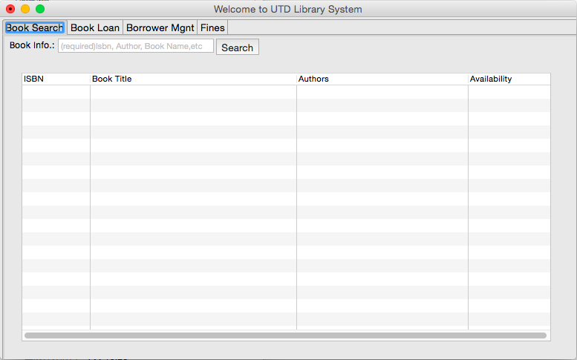
Click “Book Search”tab, input ISBN, author, book name, or any combinations of them into the search field, click “Search”, all the matched book info will be displayed in the table below, with more matches having higher priorities.

- Book Loan
  - Check Out
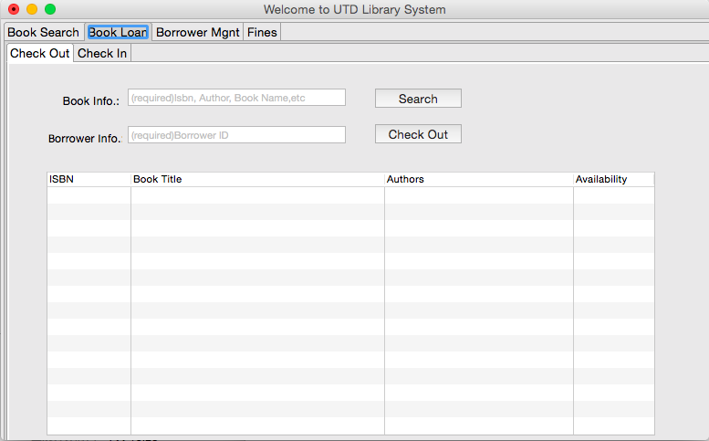
Click “Book Loan”tab, click “Check Out”subtab, input ISBN, author, book name, or any combinations of them into the search field, click “Search”, all the matched book info will be displayed in the table below, with more matches having higher priorities.
Click any record in the table, input borrower id into the borrower field, click “Check Out”, the book will be checked out with the specific card id.
Only availability is “Yes”the book can be checked out, if availability is “No”, the book cannot be checked out.
If a card id already has 3 books loaned under the id, the check out cannot be operated either.
  - Check In
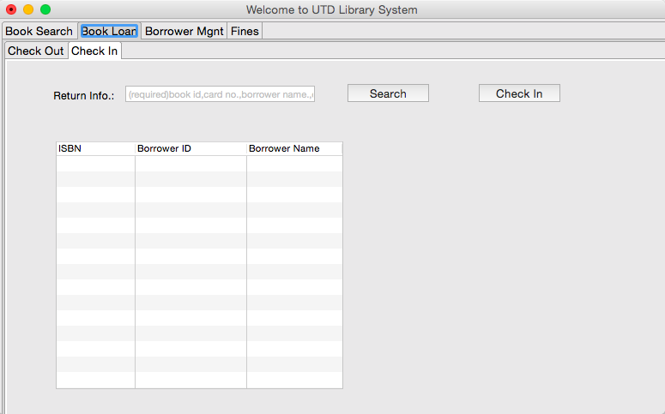
Click “Book Loan”tab, click “Check In”subtab, input book ISBN, borrower card id, borrower name, or any combinations of them, click “Search”, the related books and info will be displayed in the table below. Click “Check In”, the book will be checked in.

- Borrower Management
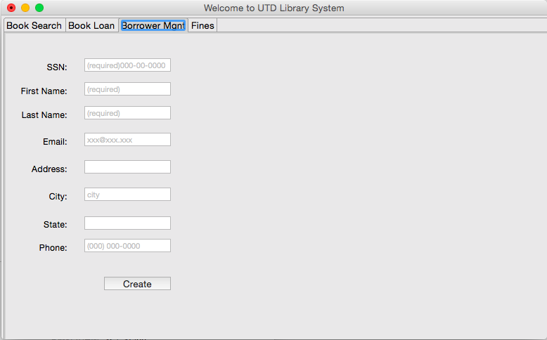
Click “Borrower Management”tab, input valid SSN, First Name, Last Name, and any other valid info. click “Create”, a new card id with the SSN will be created.

- Fines
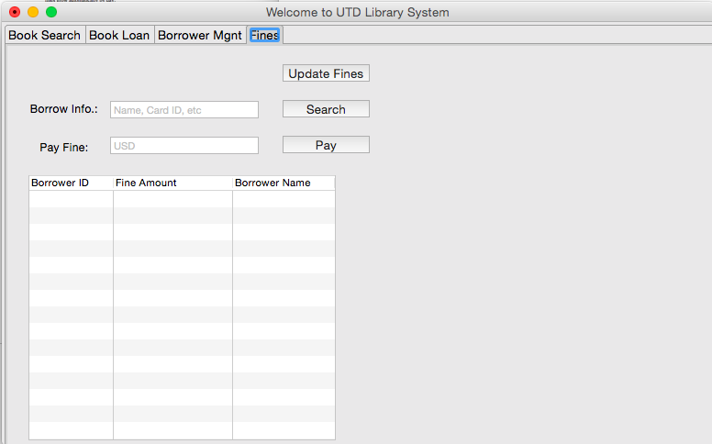
Click “Fines”tab
Click “Update Fines”, the database will be updated with all the books overdue.
Only checked in books and fines will be displayed in the table. If a fine has been paid partly or fully, the fines of this borrower will stop grow. otherwise the fines will grow by day.
Input name, card id or combination of both into the borrow info field, click “Search”, all the related info. will be displayed in the table below.
Select a record in the table, input fines to pay into the pay fine field, click “Pay”, the fines paid will be deducted from the fine amount showed and refreshed.

